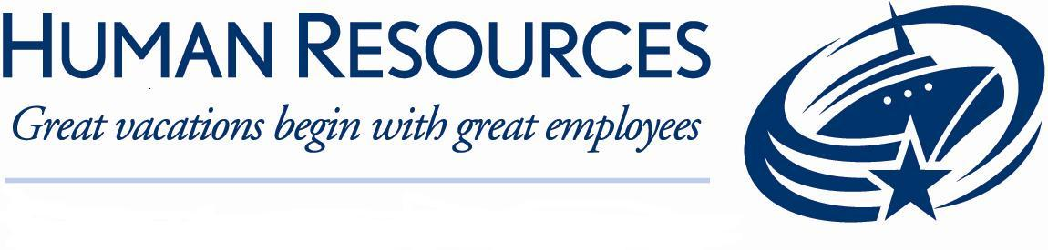

Job Description

Position Summary: Manages the daily operational aspects and the cleaning activities of Public Area team function involved with public/crew areas including the pool deck throughout the vessel.
Essential Duties and Responsibilities:
All duties and responsibilities are to be performed in accordance with Royal Caribbean International’s, SOP’s, SQM standards, USPH guidelines, environmental, and safety policies.

In accordance with Royal Caribbean International’s Royal Way Experience, each employee exemplifies friendly, passionate, committed behavior at all time. This consists of physical and verbal interactions with guests and fellow shipboard employees.

Each shipboard employee may be required to perform all functions in various areas throughout the ship.

Supports the Executive Housekeeper in the general administration involved in the overall public/crew areas cleaning function onboard the vessel, focusing primarily on quality of operations: Supervises the public/crew areas cleaning function with a staff of Public Area Attendants. Manages the assignment of duties, responsibilities and workstations to employees. Observes and evaluates employees and work procedures to ensure quality standards and service is met. Ensures proper staffing levels on a shift by shift basis as deemed adequate to execute company standards of guest service and safety.

Mentors, develops and provides on-the-job training to subordinates to strengthen their current performance and preparation for future advancement as well as executes directives deemed appropriate by the Executive Housekeeper. Utilizes and administers the disciplinary action process through coaching and counseling to improve performance or termination of employment.
Reviews financial transactions and monitors budget to ensure efficient operation, and to ensure expenditures stay within budget limitations. Reviews working hours and overtime to maintain the efficiency of the operation without exceeding budgetary constraints. Reviews requisitions estimates for product replacements, supplies, purchases, etc. and forwards to the Executive Housekeeper for final approval. Actively seeks out opportunities to reduce costs while maintaining standards of quality and service.
Ensures consistent execution of Royal Caribbean International’s The Royal Way for the cleaning function. Reviews audit comments, discusses with subordinates, and implements audit recommendations.

Monitors all cleaning processes in the public and crew areas. Inspects cleaning preparation to maintain quality standards and sanitation regulations with regard to public areas. Monitors the care, use and maintenance of all equipment, machinery, supplies, etc. for the housekeeping function. Completes all hygiene sanitation logs and ensures all USPH procedures pertaining to the Housekeeping cleaning function are followed according to the regulations.

Investigates and resolves cleaning quality and service complaints in a timely fashion, and with a view to exceeding the expectations of our guests.

Provides and monitors the Guest Service Standards on open decks, including the supervision of the cleanliness and maintenance of open decks, enforcing GVP, monitoring the Deck and Chair and Towel Programs, and monitoring the venue music on all open decks.

Investigates and resolves cleaning quality and service complaints in a timely fashion, and with a view to exceeding the expectations of our guests.

Supervises the operation of the H20 Zone, Adult Pool Deck, and all open deck spaces
Provides and monitors the Guest Service Standards on open decks, including the supervision of the cleanliness and maintenance of open decks, enforcing GVP, monitoring the Deck and Chair and Towel Programs, and monitoring the venue music on all open decks. Works with the Cruise Director, F&B Manager, Executive Housekeeper and Staff Captain to coordinate all open deck operations to ensure an optimum guest experience and safety in the open deck areas.

Works with the Cruise Director, F&B Manager, Executive Housekeeper, HMM and Staff Captain, and Bosun to coordinate the scheduling of opening, closing, cleaning and maintenance of all pools, Jacuzzis, solarium, open deck areas. Coordinate all open deck operations to ensure an optimum guest experience and safety in the open deck areas.

Understands Flow-rider and Sports Deck policies and procedures.

Manages the luggage handling process during embarkation and debarkation.

On a daily basis, meets with the Executive Housekeeper to review the requirements of the day’s activities.
Attends meetings, training activities, courses and all other work-related activities as required. Where appropriate, initiates meetings to address and resolve quality concerns and to continuously identify improvement opportunities.

Performs related duties as required. This position description in no way states or implies that these are the only duties to be performed by the shipboard employee occupying this position. Shipboard employees will be required to perform any other job-related duties assigned by their supervisor or management.

Qualifications:

Two to three years housekeeping supervisory experience in a hotel environment, preferably in a 4 or 5 star hotel both guest rooms and Public Areas preferred. Minimum one to two years previous cleaning experience, preferably in a 4 or 5 star hotel. Ability to work independently and implement proactive work measures. Ability to evaluate a situation and quickly determine the proper procedures to avoid potential problems.

Knowledge of proper cleaning techniques, requirements and use of equipment.

Knowledge of proper chemical handling.

Ability to manage the financial aspects of a cleaning operation, including the successful identification of expense reduction through cost efficiencies. Ability to manage headcount within area as it relates to and supports the business needs of the vessel.

Knowledge of principles and processes for providing customer and personal service including needs assessment techniques, quality service standards, alternative delivery systems, and customer satisfaction evaluation techniques. Ability to instruct and demonstrate customer service values into every day work practices.

Knowledge of policies and practices involved in the human resources function. Ability to manage the international staff in a positive and productive manner by motivating, developing and managing employees as they work. Ability to utilize and administer the disciplinary action process through coaching and counseling to improve performance or terminate employment.

Ability to communicate tactfully with department heads, coworkers and other shipboard employees to resolve problems and negotiate resolutions during normal operations and stressful situations.

Working knowledge of computers, Internet access, and the ability to navigate within a variety software packages such as Excel, Word, or related programs.

Completion of high school or basic education equivalency required.

Language Requirements:

- Ability to speak English clearly, distinctly and cordially with guests is a required.
- Ability to read and write English in order to understand and interpret written procedures.
- This includes the ability to give and receive instructions in written and verbal forms and to effectively present information and respond to questions from guests, supervisors and fellow crew.

Physical Demands:
- While performing the duties of this job, the shipboard employee is regularly required to stand, walk, use hands to touch, handle, or feel, reach with hands and arms, talk or hear, and taste or smell. Specific vision abilities required by this job include close vision, distance vision, color vision, peripheral vision, depth perception, and ability to adjust focus.

- All shipboard employees must be physically able to participate in emergency lifesaving procedures and drills. Full use and range of arms and legs as well as full visual, verbal and hearing abilities are required to receive and give instructions in the event of an emergency including the lowering of lifeboats. Ability to lift and/or move up to 50 pounds.

“This position will frequently require schedule rotation between Public Area and Accommodation”

